**DS 501 STATISTICAL & MATHEMATICAL METHODS FOR DATA SCIENCE**

**ASSIGNMENT 8**

Name: Hussam-Ul-Hussain Roll Number: 18L-1827

Make sure everything fits in the space below. Also, your plots should be saved as jpg files before being pasted here. ADD LABELS TO ALL AXIS IN PLOTS AND DO NOT PASTE SCREEN SHOTS.

**QUESTION 1:** How did you map the values of predictions from the model to labels. Give an exact mathematical expression (Write all math properly):

X = |TestingPrediction - 1|

Y = |TestingPrediction + 1|

FOR i = 1:SIZE(TestingPrediction) {

MINIMUM = min(X(i),Y(i))

IF MINIMUM = 1

Prediction(i) = 1

IF MINIMUM = 2

Prediction(i) = -1

}

**QUESTION 2:** **RESULTS**

Plot of data points and hyperplane compute for SV with alpha>1e-5 and upperbound of fmincon as a vector of 10’s.

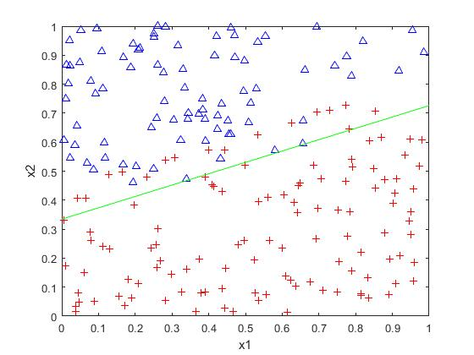

|  |  |  |  |
| --- | --- | --- | --- |
|  | Actual + | Actual - | Total |
| Predicted + | TP = 24 | FP = 1 | 25 |
| Predicted  - | FN = 5 | TN = 21 | 26 |
| Total -> | 29 | 22 | 51 |

BAC = 0.891066

Weight Vector = [ 21.5720, -47.3558]T  w0 = 14.429653

Plot of data points and hyperplane compute for SV with alpha>1e-2 and upperbound of fmincon as a vector of 1s.

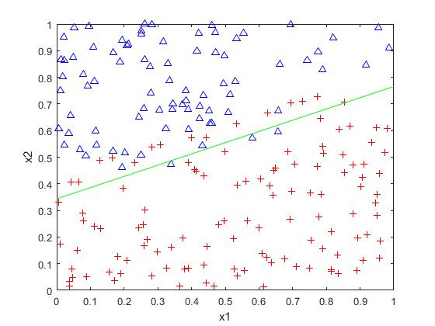

|  |  |  |  |
| --- | --- | --- | --- |
|  | Actual + | Actual - | Total |
| Predicted + | TP = 25 | FP = 1 | 26 |
| Predicted  - | FN = 4 | TN = 21 | 25 |
| Total -> | 29 | 22 | 51 |

BAC = 0.908307

Weight Vector = [9.4898, -22.1522]T  w0 = 7.559520

Plot of data points and hyperplane compute for SV with alpha>1e-8 and upperbound of fmincon as a vector of 5’s.

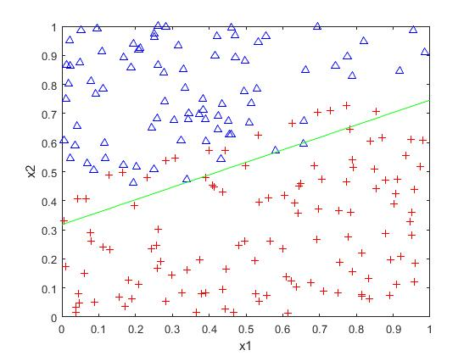

|  |  |  |  |
| --- | --- | --- | --- |
|  | Actual + | Actual - | Total |
| Predicted + | TP = 24 | FP = 1 | 25 |
| Predicted  - | FN = 5 | TN = 21 | 26 |
| Total -> | 29 | 22 | 51 |

BAC = 0.891066

Weight Vector = [20.4496, -46.8280]T  w0 = 14.686848

Plot of data points and hyperplane compute for SV with alpha>1 and upperbound of fmincon as a vector of 100’s.

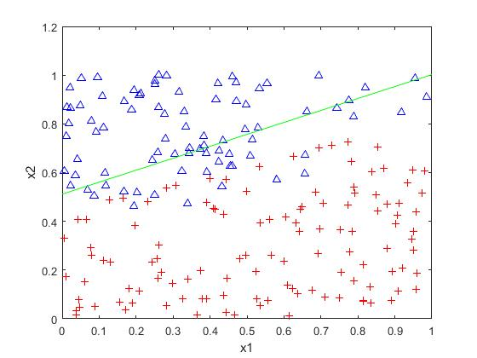

|  |  |  |  |
| --- | --- | --- | --- |
|  | Actual + | Actual - | Total |
| Predicted + | TP = 29 | FP = 8 | 37 |
| Predicted  - | FN = 0 | TN = 14 | 14 |
| Total -> | 29 | 22 | 51 |

BAC = 0.818182

Weight Vector = [19.3663, -46.7080]T  w0 = 25.812539

Plot of data points and hyperplane compute for SV with alpha>0 and upperbound of fmincon as a vector of -1’s.

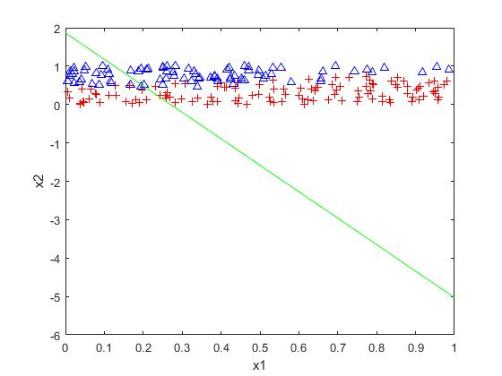

|  |  |  |  |
| --- | --- | --- | --- |
|  | Actual + | Actual - | Total |
| Predicted + | TP = 18 | FP = 19 | 37 |
| Predicted  - | FN = 11 | TN = 3 | 14 |
| Total -> | 29 | 22 | 51 |

BAC = 0.378

Weight Vector = [4.6705, 2.1143]T  w0 = -2.234386

**QUESTION 3:** Give YOUR opinion or conclusions about the results in two or three lines.

W0 defines the y-intercept of the line and Weights defines the slope of the line. Here W0 is the average of all the Support Vectors where alpha = 1. Here Upper Bound defines the boundary for blue triangles and Lower Bound defines the boundary for red crosses.